EX NO:07 CREDIT CARD PROCESSING SYSTEM
1.USECASE DIAGRAM:
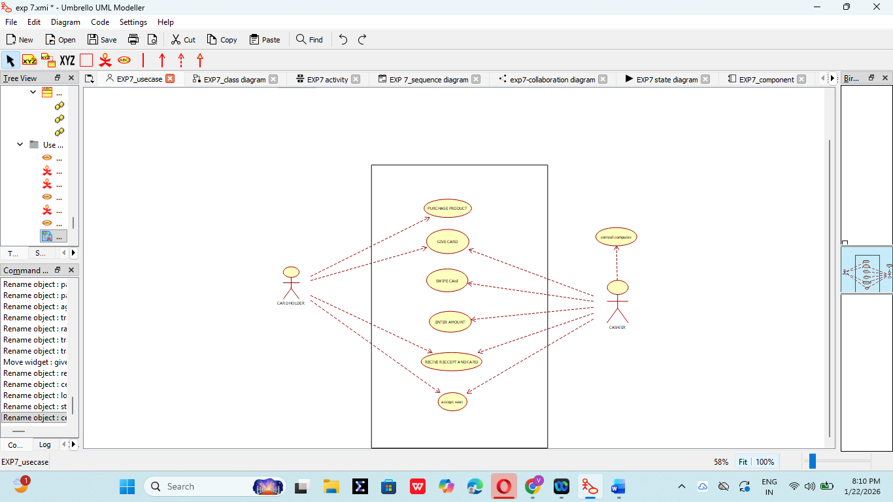

2. CLASS DIAGRAM:
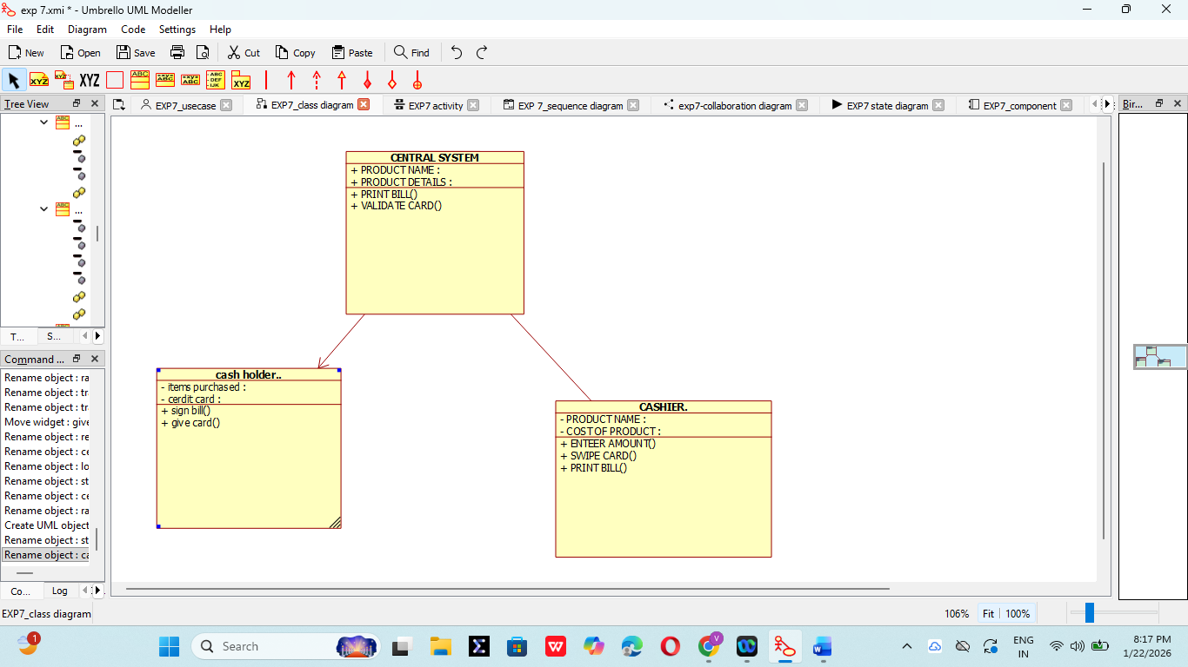
3. ACTIVITY DIAGRAM:
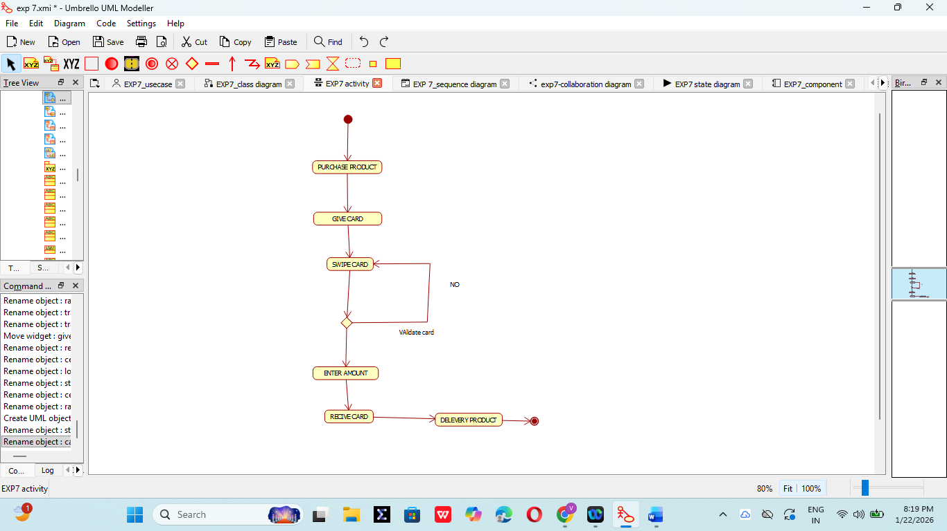

4. SEQUENCE DIAGRAM:
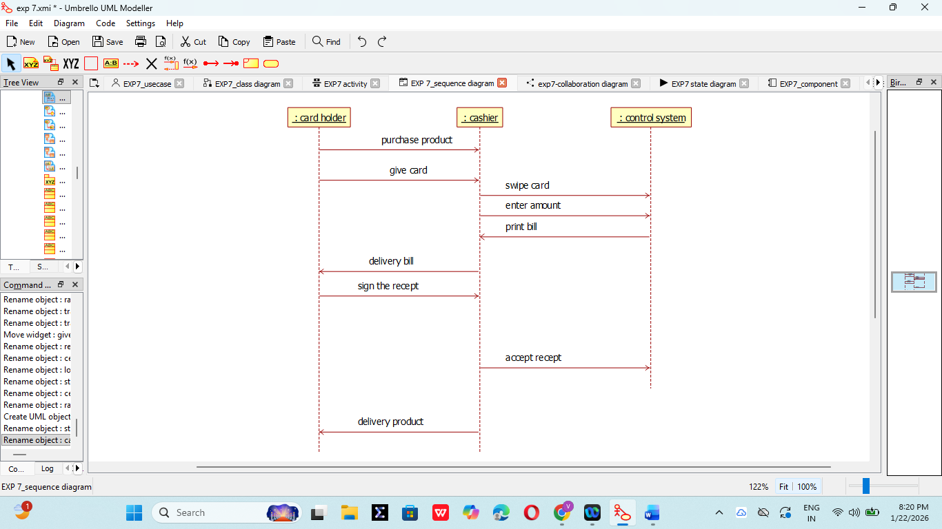

5. COLLABORATION DIAGRAM:
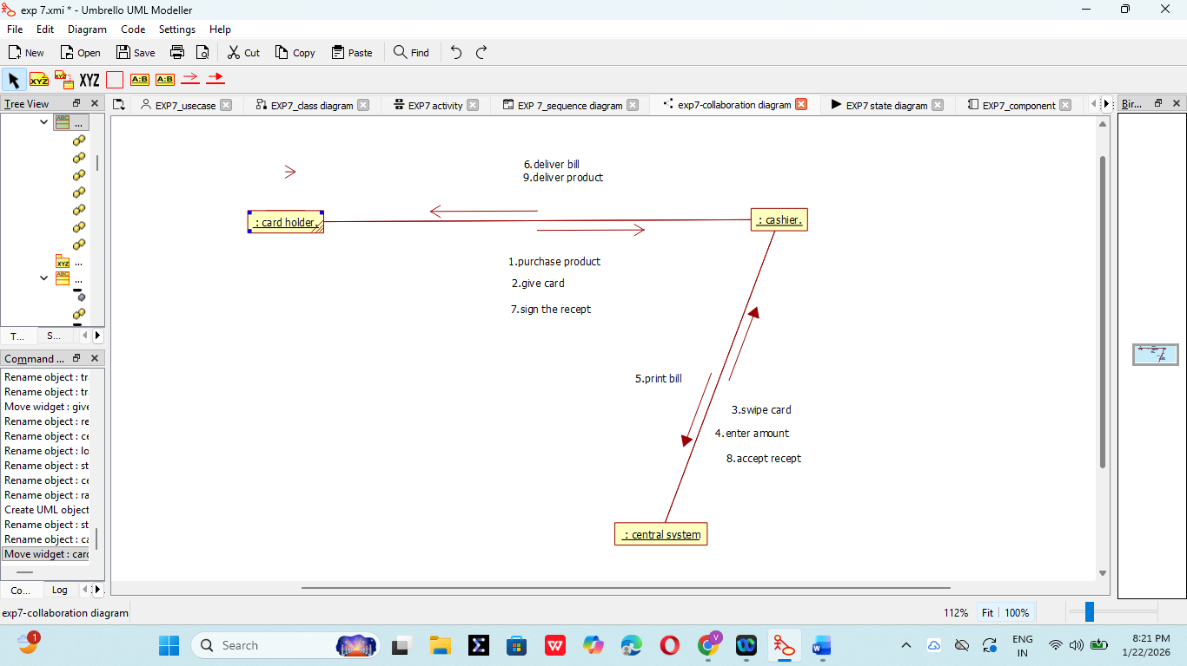

6. STATE CHART DIAGRAM:
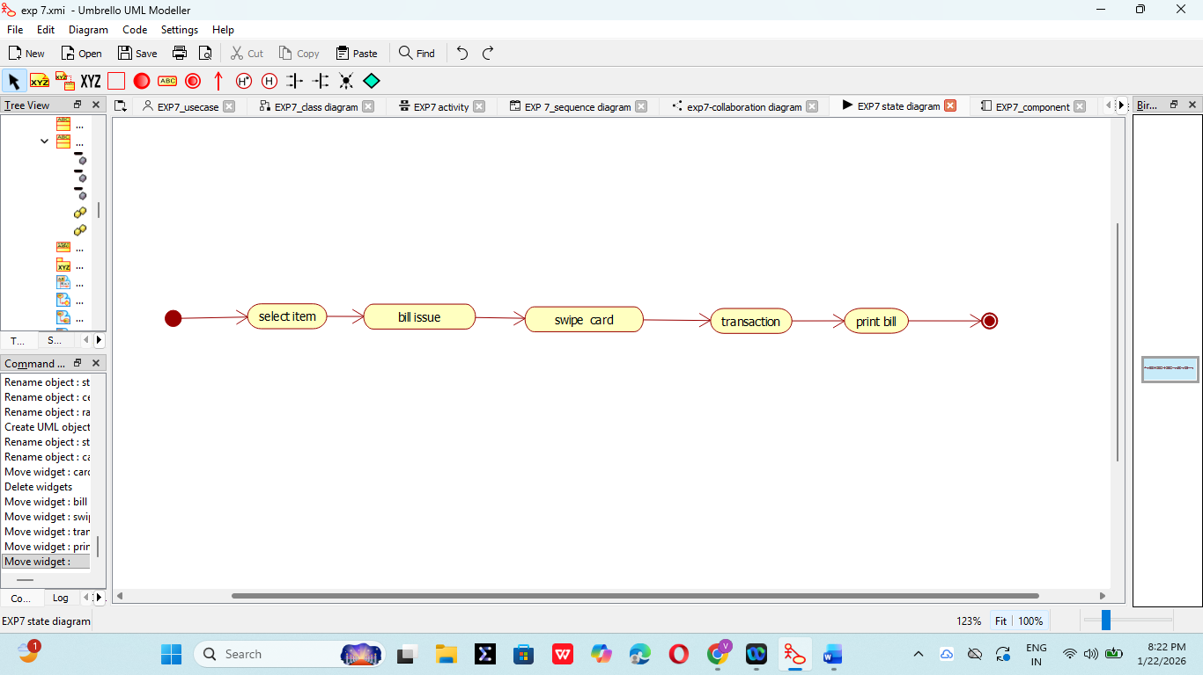

7. COMPONENT DIAGRAM:
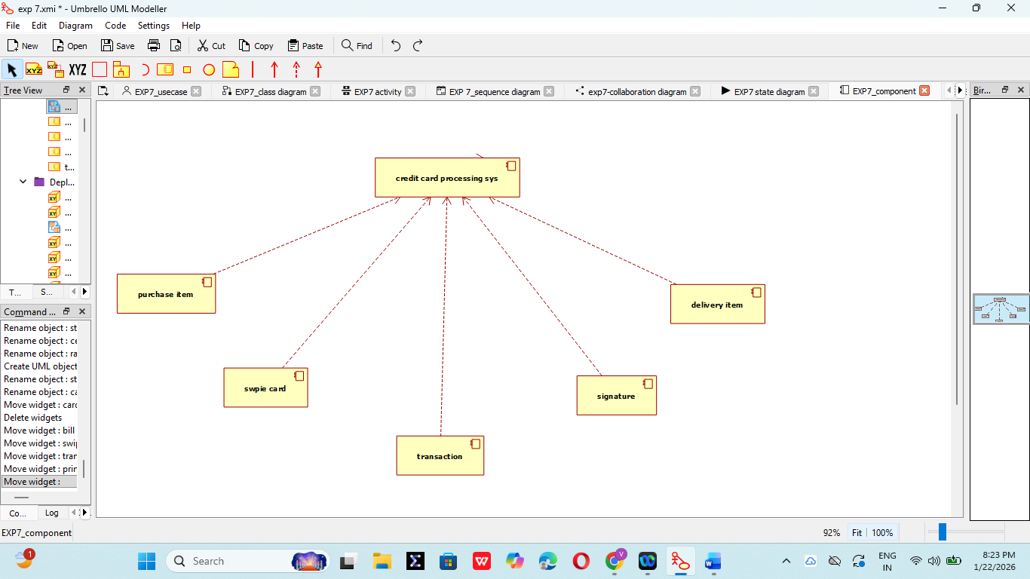

8. DEPLOYMENT DIAGRAM:
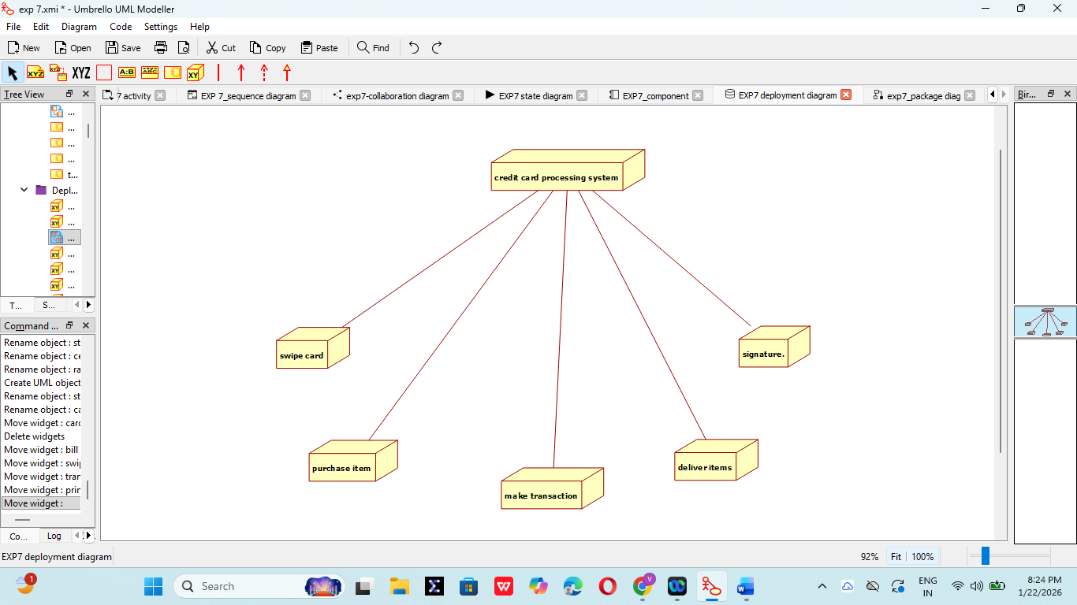

9. PACKAGE DIAGRAM:
